LAB # 01
OBJECTIVE:
Understand the fundamentals of deep learning and its real-world applications, set up a Python environment for deep learning, and perform basic operations using TensorFlow and Scikit-learn.
LAB TASKS:
- Create a random float Tensor and compute sum, mean, maximum.
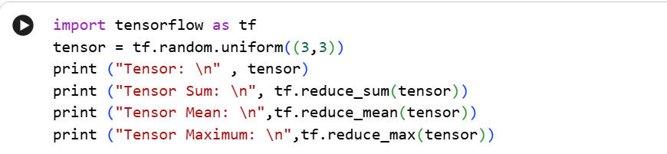
CODE:
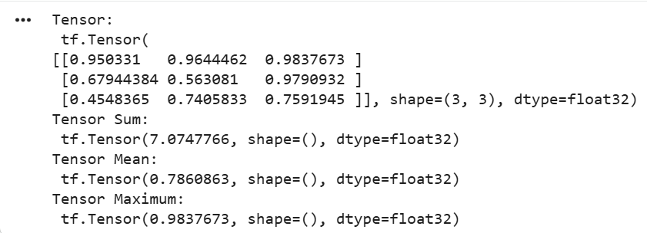
OUTPUT:
- Create a 3D TensorFlow tensor and access a specific element, extract a 2D slice, and extract a 1D slice.
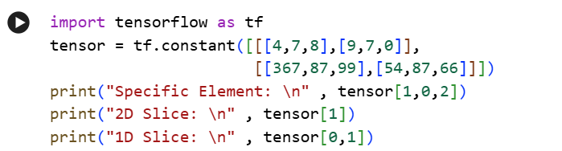
CODE:
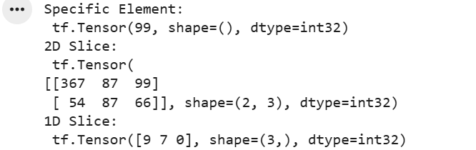
OUTPUT:
- Create a NumPy array with random float values. Sort the array in ascending and descending order.
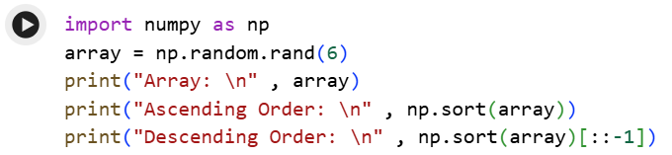
CODE:
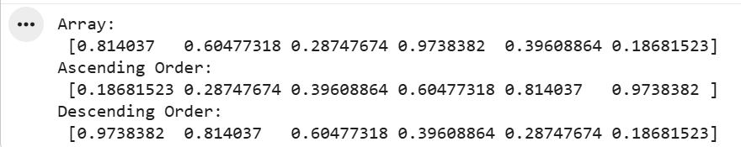
OUTPUT:
- Create a 2x2 NumPy matrix. Calculate its transpose and inverse.
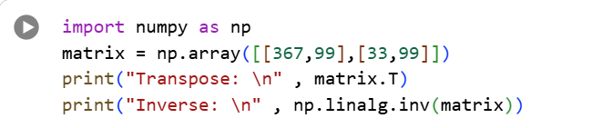
CODE:
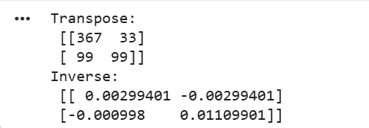
OUTPUT:
- Create a 2D NumPy array. Calculate the sum of each row, the mean of each column, and the standard deviation of the entire array.
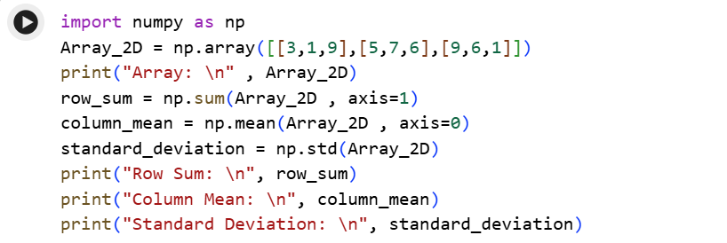
CODE:
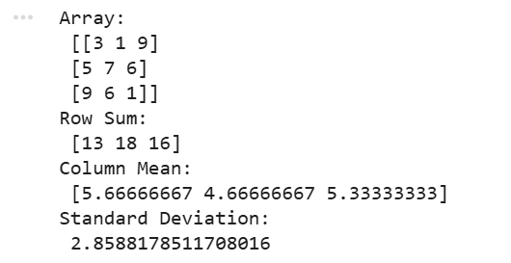
OUTPUT:
BONUS TASKS:
- Convert a NumPy array to a TensorFlow tensor.
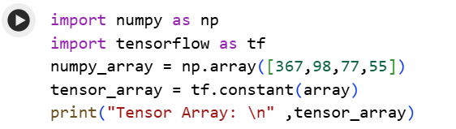
CODE:
OUTPUT:
- Perform tensor operations (addition, multiplication) on this tensor.
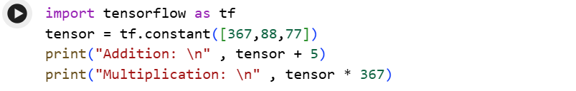
CODE:
OUTPUT:
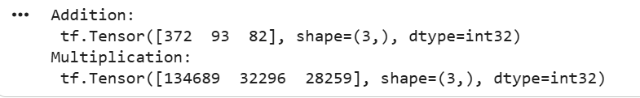
- Design a function that:
- Accepts a NumPy array as input
- Converts it into a TensorFlow tensor
- Adds 10 to each element
- Returns the updated tensor
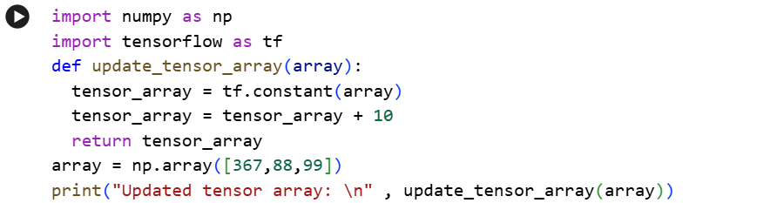
CODE:
OUTPUT:

